

**Course Code:** CSE 1202

# **Course Title:** Structured Programming Lab

**Section:** 03

# Summer 2024

***Lab Report 1***

**Submitted to:**

# Jannatul Ferdous Ruma

# Lecturer

Department of Computer Science and Engineering (CSE)

# ULAB School of Science & Engineering

# University of Liberal Arts Bangladesh

**Submitted by:**

# **Name:** Mustakim Ahamed Siam

# **ID:** 241014108

# **Date:** June 27, 2024

1. Write a program to find the largest and smallest among three entered numbers and also

display whether the identified largest/smallest number is even or odd.

**Answer:**

#include <stdio.h>

int main() {

int num1, num2, num3,largest,smallest;

printf("Enter three numbers: ");

scanf("%d %d %d", &num1, &num2, &num3);

largest = num1;

if (num2 > largest) {

largest = num2;

}

if (num3 > largest) {

largest = num3;

}

smallest = num1;

if (num2 < smallest) {

smallest = num2;

}

if (num3 < smallest) {

smallest = num3;

}

if (largest % 2 == 0) {

printf("The largest number %d is even\n", largest);

} else {

printf("The largest number %d is odd\n", largest);

}

if (smallest % 2 == 0) {

printf("The smallest number %d is even\n", smallest);

} else {

printf("The smallest number %d is odd\n", smallest);

}

return 0;

}

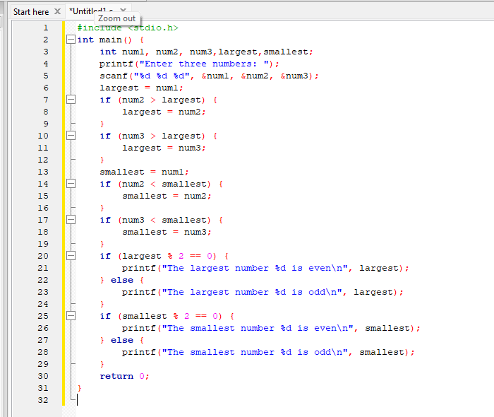

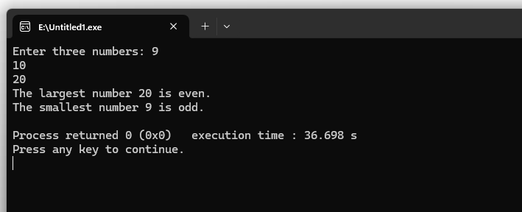

2. Write a program that asks a number and test the number whether it is multiple of 5,

divisible by 7 but not by eleven.

**Answer:**

#include <stdio.h>

int main() {

int number;

printf("Enter a number: ");

scanf("%d", &number);

if (number % 5 == 0 && number % 7 == 0 && number % 11 != 0) {

printf("%d satisfies the conditions (multiple of 5, divisible by 7 but not by 11)\n", number);

} else {

printf("%d does not satisfy the conditions.\n", number);

}

return 0;

}

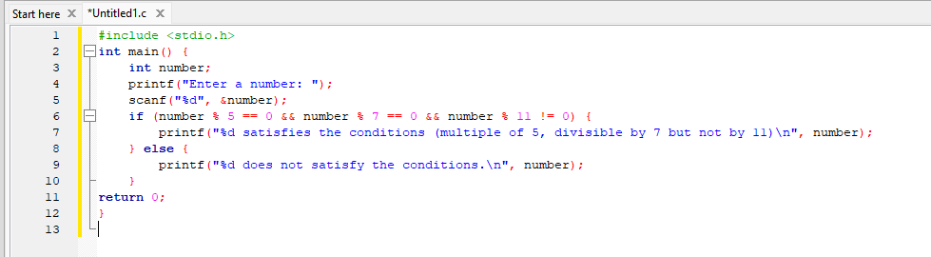

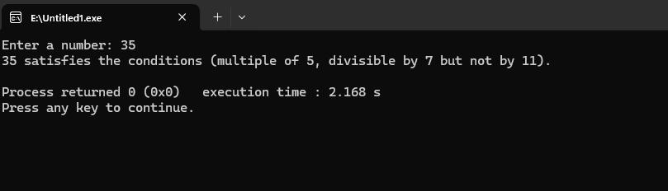

3. Write a program to check whether the entered year is leap year or not (a year is leap if it

is divisible by 4 and divisible by 100 or 400.)

**Answer:**

#include <stdio.h>

int main() {

int year;

printf("Enter a year: ");

scanf("%d", &year);

if ((year % 4 == 0 && year % 100 != 0) || (year % 400 == 0)) {

printf("%d is a leap year.\n", year);

} else {

printf("%d is not a leap year.\n", year);

}

return 0;

}

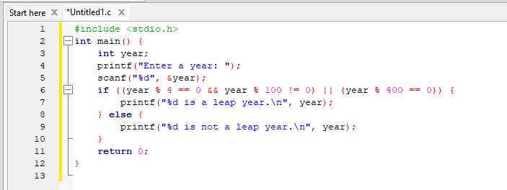

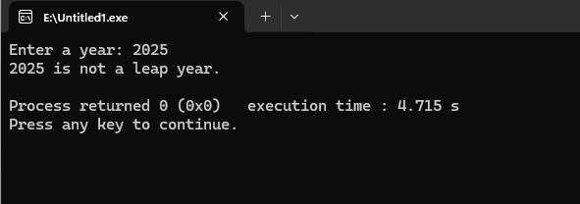

4. Write a program that will give a choice menu. Using if for coding

Take two inputs and one operator and do the calculation.

Press ‘+’: Add two numbers

Press ‘-’: Subtract two numbers

Press ‘*’: Multiply two numbers

Press ‘/’: Division two numbers

**Answer:**

#include <stdio.h>

int main() {

float num1, num2, result;

char operator;

printf("Enter first number: ");

scanf("%f", &num1);

printf("Enter second number: ");

scanf("%f", &num2);

printf("Enter the operator (+, -, *, /): ");

scanf(" %c", &operator);

if (operator == '+') {

result = num1 + num2;

} else if (operator == '-') {

result = num1 - num2;

} else if (operator == '*') {

result = num1 * num2;

} else if (operator == '/') {

if (num2 != 0) {

result = num1 / num2;

} else {

printf("Error: Division by zero\n");

}

} else {

printf("Error: Invalid operator\n");

}

printf("Result: %f\n", result);

return 0;

}

